

CSF302
Software Engineering Department

Lab Report 3

<Submitted by> Student No:02240337

Royal University of Bhutan, College of Science and Technology

Square Matrix Multiplication

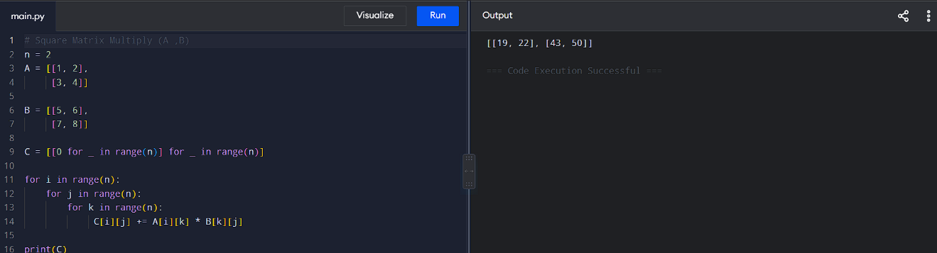

Reflection
During this practical, I learned how matrix multiplication works step by step. I understood how nested loops calculate each element of the result by summing products of corresponding entries.

This helped me connect the theory of linear algebra with actual code implementation, strengthening both my programming and mathematical skills.

